**Homework 5**

Problem 1.

Create a Web Page like the following. Choose your own idea, colors, pictures, video and map!

#### Use [PT Sans](https://fonts.google.com/specimen/PT+Sans?selection.family=PT+Sans) for the text. Create files: "index**.html**" and "style**.css**"

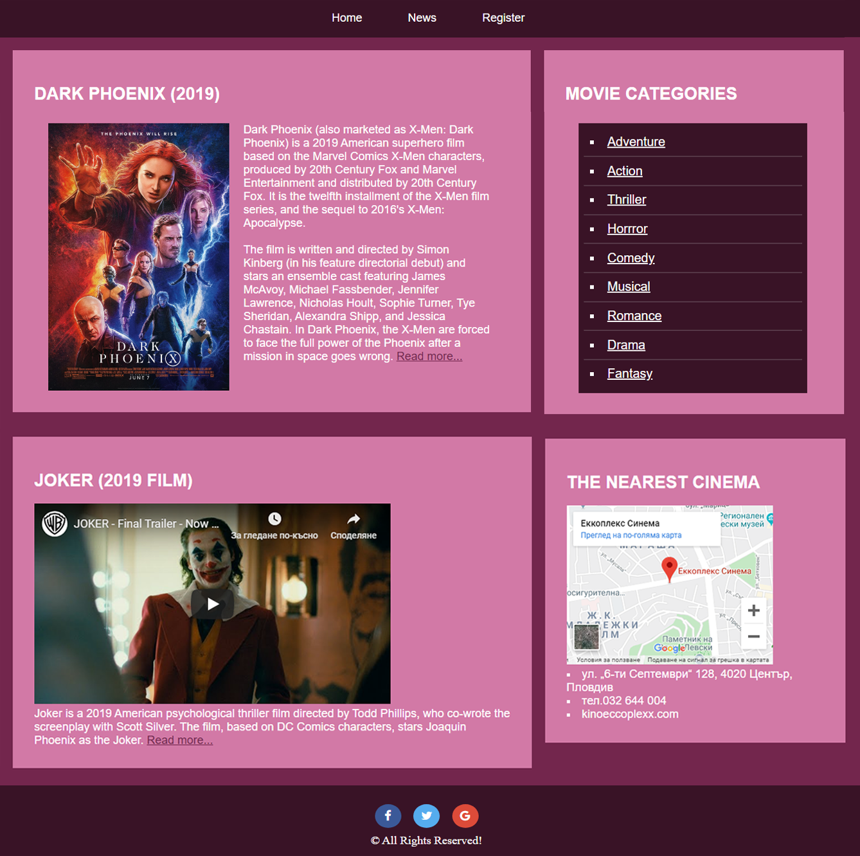

Problem 2.

Create a Web Page like the following. Make sure you connect two of the pages!

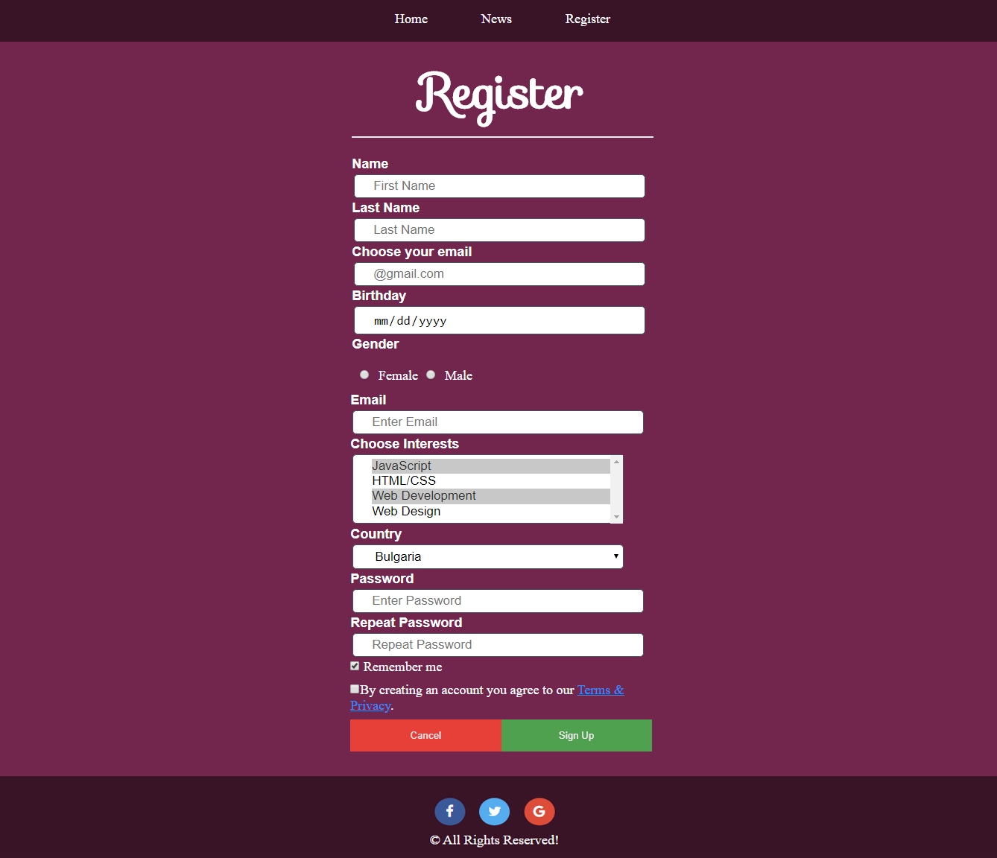

#### Use [Sofia](https://fonts.google.com/specimen/Sofia?selection.family=Sofia) for the text. Create files: "register.html" and "style-register.css"